EFT punten
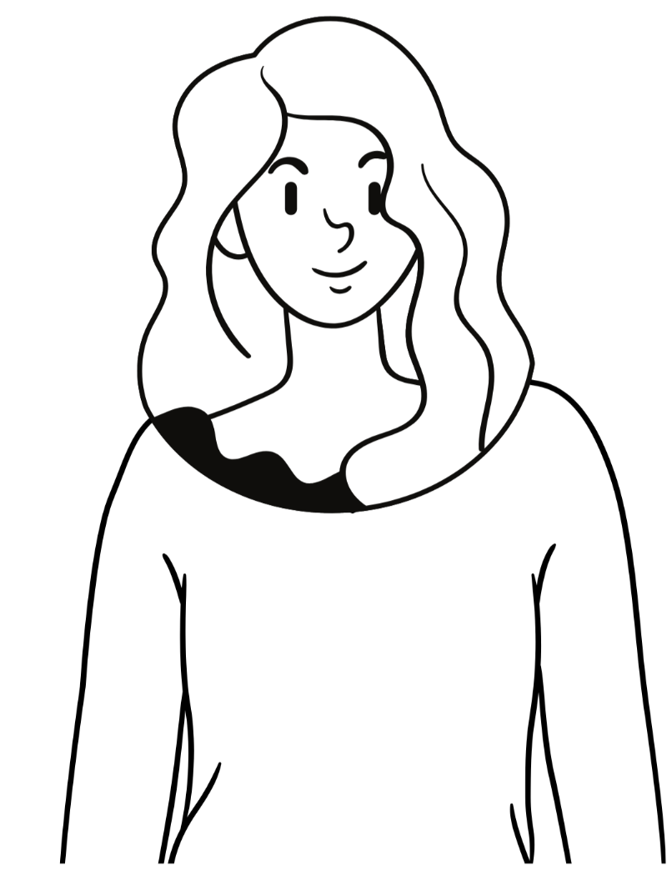
Top of the head

Eyebrow point

Under the eye
Side of the eye

Under the nose
chin

under the armpit
under the
collarbone

Start with the “karate checkpoint” and say:
Even though (dscribe problem/question or theme)…………………………………………………. I deeply and completely accept myself. repeat 3 times. Than go through the tapping points as shown above starting with the eyebrow point. Tapp minimal of 7 times on each point.

